Dear UPrep Families,

We hope this letter finds you well.

According to the Ohio Department of Health (ODH) schools that do not provide the services of a nurse and/or health professional to their students must provide the following information to families in order to get their son or daughter screened for Developmental Disorders. Developmental disabilities are a group of conditions due to impairment in physical, learning, language, or behavior areas. These conditions begin during the developmental period, may impact day-to-day functioning, and usually last throughout a person’s lifetime.

To find a healthcare professional that can assist with developmental disabilities, please visit: <http://providersearch.dodd.ohio.gov/> and click “Start a Search”.

If you have any further questions please contact the school’s front office

Sincerely,

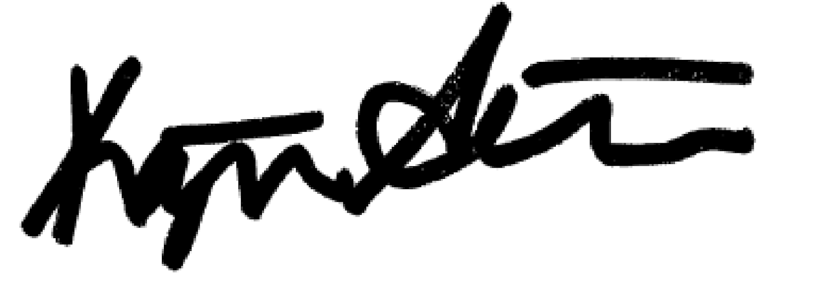  
  
Kathryn Anstaett

Chief Schools Officer